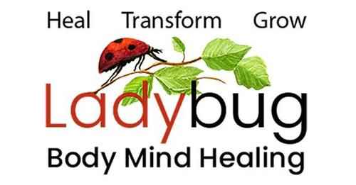
Leslie Gould-Barkman, MSW. ECP1. BCP2. BCTMB. MCLC.
Somatic Therapist - Certified Emotion & Body Code Practitioner – Akashic Record Soul Readings
West Hatfield, MA 413-320-9365

Emotion & Body Code for Pets Informed Consent Form

I_____________________________________, understand that the Emotion & Body Code treatments given to my pet by Leslie Gould-Barkman of Ladybug Body-Mind Healing do not take the place of medical advice or treatments from a veterinarian. It is intended to supplement Veterinary care for the purpose of stress reduction, easing discomfort and removing emotional and physical imbalances in the system. I understand that Leslie Gould-Barkman does not diagnose or prevent illness, or any other disorder nor does she make predictions or offer spiritual advice. I understand that these treatments are not a substitute for medical examinations or care, and that it is recommended to work in conjunction with my veterinarian for any condition my pet may have.
The following statement is required to maintain liability insurance: “Except in the case of gross negligence or malpractice, I or my representative(s) agree to fully release and hold harmless Leslie Gould-Barkman and Ladybug Body-Mind Healing from any and all claims or liability of whatsoever kind or nature arising out of or in connection with my session(s).
Cancellation Policy
Please note that a 24-hour advance notice of cancellation is required. In the event of a no-show or last-minute cancellation the client agrees to pay the cost of the missed session unless it is an emergency or it can be rescheduled within the same week. I have read the above informed consent, understand, and agree to it.

Client Printed Name: ____________________________________________________________ Client Signature_________________________________________________________________
Pet’s Name: ____________________________________________________________________ Date: ____________________

