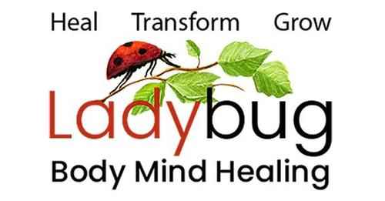
Leslie Gould-Barkman, MSW. ECP1. BCP2. BCTMB. MCLC.
Somatic Therapist - Certified Emotion & Body Code Practitioner – Akashic Record Soul Readings
West Hatfield, MA 413-320-9365

Emotion & Body Code for Pets Intake Form

Date: ________________
Your Name: ___________________________________________________________________
Address: __________________________________________ City: _______________________
State: __________________ Zip Code: _______________Email: _________________________

Your Pets Name____________________ Type of Pet: ______________________ Age: _______
Breed: ________________ Gender: ______ Veterinarian: _______________________________

May I include you on my email list for updates, events, and occasional newsletters? Yes No
Home Phone: __________________________ May I leave a message at this number? Yes No
Cell Phone: ____________________________ May I leave a message at this number? Yes No
Work Phone: ___________________________May I leave a message at this number? Yes No

Preferred Method of Communication: Text: __ Phone Call: __ Email: __

Where or from whom did you learn about Ladybug Body-Mind Healing?
Online if so, where? ______________________________________________________________________________
Friend, neighbor, family, colleague? ______________________________________________________________________________
Other? ________________________________________________________________________

What brings you and your pet to Ladybug Body-Mind Healing and what do you hope to accomplish? ________________________________________________________________________________________________________________________________________________________________________________________________________________________________________________________________________________________________________________________

List the emotional/physical/behavioral symptoms you would like to reduce or eliminate: _______________________________________________________________________________________________________________________________________________________________________________________________________________________________________________________________________________________________________________________
Prior experience with the Emotion/Body Code or Energy Healing? __________________________________________________________________________________________________________________________________________________________________________________________________________________________________________
Medical conditions, history, treatment and current medications: ______________________________________________________________________________________________________________________________________________________________________________________________________________________________________________________________________________________________________________________________________________________________________________________________________
Anything else you think I should know? ________________________________________________________________________________________________________________________________________________________________________________________________________________________________________________________________________________________________________________________

