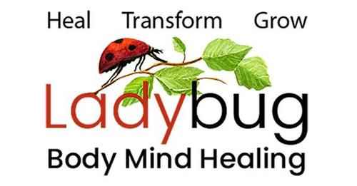
Leslie Gould-Barkman, MSW. ECP1. BCP2. BCTMB. MCLC.
Somatic Therapist - Certified Emotion & Body Code Practitioner – Akashic Record Soul Readings
West Hatfield, MA 413-320-9365

Client Informed Consent
My work with clients is versatile and may involve the application of various tools and techniques that can enhance our work together including somatic therapy, the Emotion & Body Code, spiritual readings, energy clearings and the use of other self-help and wellness approaches. Like any other treatments and therapies these techniques may also have unintended negative side effects such as sleep disturbances, unpleasant memories, or unfamiliar or uncomfortable body sensations. Such reactions are not uncommon and usually change as we continue working, and it is your responsibility to let me know when you are uncomfortable with any part of the treatment. All therapeutic work including any hands on or energy work is strictly at a professional and not personal level. You have the right to refuse or terminate treatment at any time or to refuse any intervention I may propose or employ. If you have any questions about any of the techniques I offer, please ask and I will do my best to answer your questions and provide information and resources.
Client Agreement
I_____________________________________, understand that the treatment given to me by Leslie Gould-Barkman of Ladybug Body-Mind Healing is for the purpose of stress reduction, personal growth and healing. I understand that Leslie Gould-Barkman does not diagnose or prevent physical or mental illness, or any other disorder nor does she make predictions or offer spiritual advice. I understand that these treatments are not a substitute for medical or psychological examinations or care, and that it is recommended to work in conjunction with my doctor or mental health professional who can diagnose for any condition I may have.
The following statement is required to maintain liability insurance: “Except in the case of gross negligence or malpractice, I or my representative(s) agree to fully release and hold harmless Leslie Gould-Barkman and Ladybug Body-Mind Healing from any and all claims or liability of whatsoever kind or nature arising out of or in connection with my session(s).
Cancellation Policy
Please note that a 24-hour advance notice of cancellation is required. In the event of a no-show or last-minute cancellation the client agrees to pay the cost of the missed session unless it is an emergency or can be rescheduled for the same week. I have read the above informed consent, understand, and agree to it.

Client Printed Name: ________________________________________________________________________
Client Signature: __________________________________________________Date: ____________________

