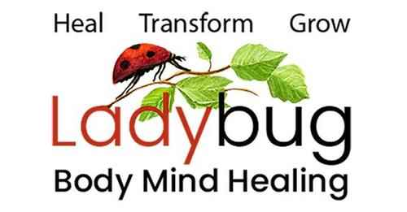
Leslie Gould-Barkman, MSW. ECP1. BCP2. BCTMB. MCLC.
Somatic Therapist - Certified Emotion & Body Code Practitioner – Akashic Record Soul Readings
West Hatfield, MA 413-320-9365

Client Intake Form

Date: ________________
Your Name: ___________________________________________Date of Birth______________
Address: __________________________________________ City: _______________________
State: __________________ Zip Code: _______________Email: _________________________

May I include you on my email list for updates, events, and occasional newsletters? Yes No
Home Phone: __________________________ May I leave a message at this number? Yes No
Cell Phone: ____________________________ May I leave a message at this number? Yes No
Work Phone: ___________________________May I leave a message at this number? Yes No

Preferred Method of Communication: Text: __ Phone Call: __ Email: __

Where or from whom did you learn about Ladybug Body-Mind Healing?
Online if so, where? ______________________________________________________________________________
Friend, neighbor, family, colleague? ______________________________________________________________________________
Other? ________________________________________________________________________

What brings you to Ladybug Body-Mind Healing and what do you hope to accomplish? ________________________________________________________________________________________________________________________________________________________________________________________________________________________________________________________________________________________________________________________

List the emotional and/or physical symptoms you would like to reduce or eliminate: ______________________________________________________________________________________________________________________________________________________________________________________________________________________________________________________________________________________________________________________________________________________________________________________________________

Prior experience with Somatic (Body-Mind) Therapy, The Emotion/Body Code, Energy Healing or Spiritual Guidance? __________________________________________________________________________________________________________________________________________________________________________________________________________________________________________
Medical conditions, history, treatment, and current medications: ______________________________________________________________________________________________________________________________________________________________________________________________________________________________________________________________________________________________________________________________________________________________________________________________________Anything else you think I should know? ________________________________________________________________________________________________________________________________________________________________________________________________________________________________________________________________________________________________________________________

