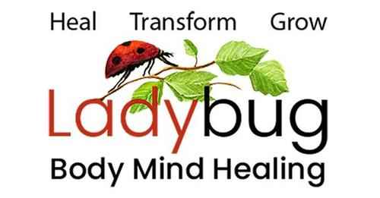
Leslie Gould-Barkman MSW. LCSW. LMT.
West Hatfield, MA 01088 413-320-9365

Sample Questions for the Akashic Records
Personal:
• What is my purpose?
• What is my next step?
• What do I need to know in order to take my next step forward?
• What is blocking me from taking that first step?
• What skills, aptitudes and gifts do I bring to this life from previous lives?
• What past lives need the most healing at this time?
• What patterns do I need to let go of?
• What skills do I need to develop?
• What past life (lives) need the most attention at this moment?
• What is my soul’s mission and purpose?
• What are the lessons I need to learn from this life?
• How does this life fit my life purpose?
• How do the difficulties in my life serve my higher purpose?
• What patterns of procrastination do I have and why and how can I heal them?
• What am I most afraid of in terms of taking my next step forward?
• What are my greatest gifts yet to be discovered? How can I move toward them?
• How can I take better care of myself?
• I have a medical issue (name), what is this about and how am I to learn about it?
• Tell me about a lifetime(s) of being harmed for being a healer/in my power.
• Tell me about a lifetime(s) where I was fully in my power.
• How do the fears from past lives block me in this lifetime? How does my current life fit
with this?
• Tell me about the flavors of my lifetimes. What has been the theme for me throughout?
What qualities and gifts have I shared along the way?
• Tell me about a lifetime(s) where I was in the darkness or misused my power. What was
I trying to learn and how can I let go of my fear/shame/guilt about this?
• Please help me with my guilt and shame. Where does it stem from? How can I heal it?
• Please help me with my phobia. Where does it stem from? How can I heal it?

Professional:
• Why am I so sensitive to other’s emotions?
• How can I set better boundaries?
• Why do I have scarcity issues around money?
• Why is it difficult for me to charge money for my work, get a good paying job or ask for
a raise?
• What do I need to know/let go of to attract a higher salary or attract more business?
• Where does God/My Higher Power want me to work/what kind of work right now?
• How is my current job serving me?
• How can I bring my full potential/power to the job I have?
Family/Relationships:
• What do I need to do to get along with the people I live with?
• Why was I born into this family? How does it serve my higher purpose?
• How can I repair the relationship with my family?
• Why do I have an issue with (name)?
• Are we connected in a past life? If so, which ones and how can we heal?
• What do I need to know to resolve the relationship with (name)?
• How does the struggle with (name) serve my higher purpose?
• Why am I related to/working with this difficult person? What am I trying to learn from
him/her?
Planetary:
• Where are we going as a planet? How may I help its (our) higher purpose?
• What is the best use of my volunteer time? Where?
• Why is there so much tragedy in the world at this time?
• What is in the way of our country’s evolution?

