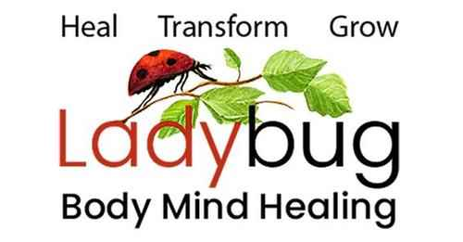
Leslie Gould-Barkman MSW. LCSW. LMT.
West Hatfield, MA 01088 413-320-9365

Disclaimer for Non-Massachusetts Residents

I understand that Leslie Gould-Barkman offers two services– one as a licensed psychotherapist in Massachusetts, and the other as a spiritual & intuitive counselor and energy therapist.

I understand that as a licensed social worker in the state of Massachusetts, Leslie Gould-Barkman is only permitted to practice as a psychotherapist with Massachusetts residents.

By signing below, I am agreeing to see Leslie Gould-Barkman for spiritual & intuitive counseling and energy therapy. This service may include spiritual readings, hands on and energetic healing, hypnotherapy, and holistic counseling which are unregulated in the state of Massachusetts.

Client’s Printed Name: ___________________________________________________________
Client’s Signature: _______________________________________________________________
Date: ________________________

